**Phase 2: Org Setup & Configuration – Student Management System**

**1. Salesforce Edition**

* **Developer Edition** (Dev Org) used for project setup.

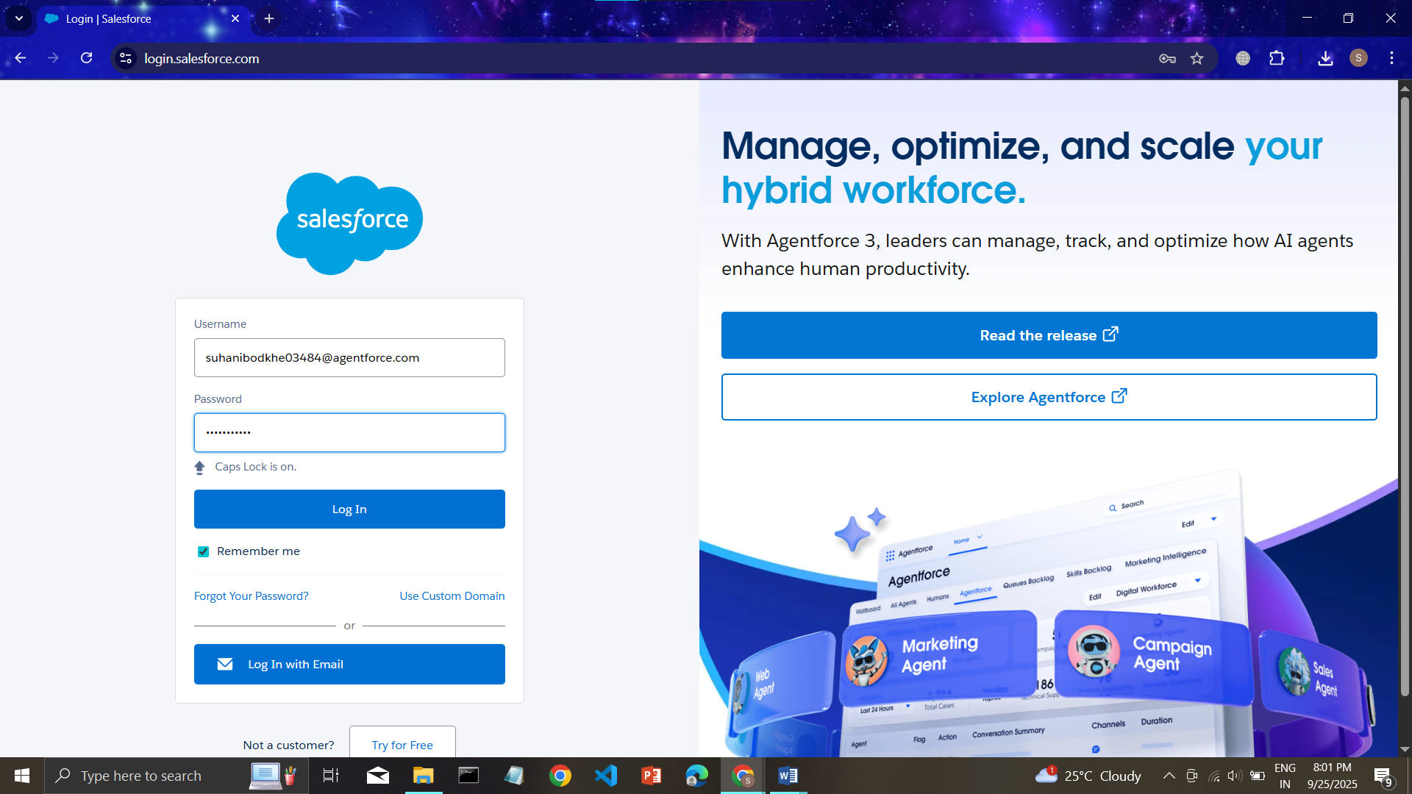

**2. Company Profile Setup**

* 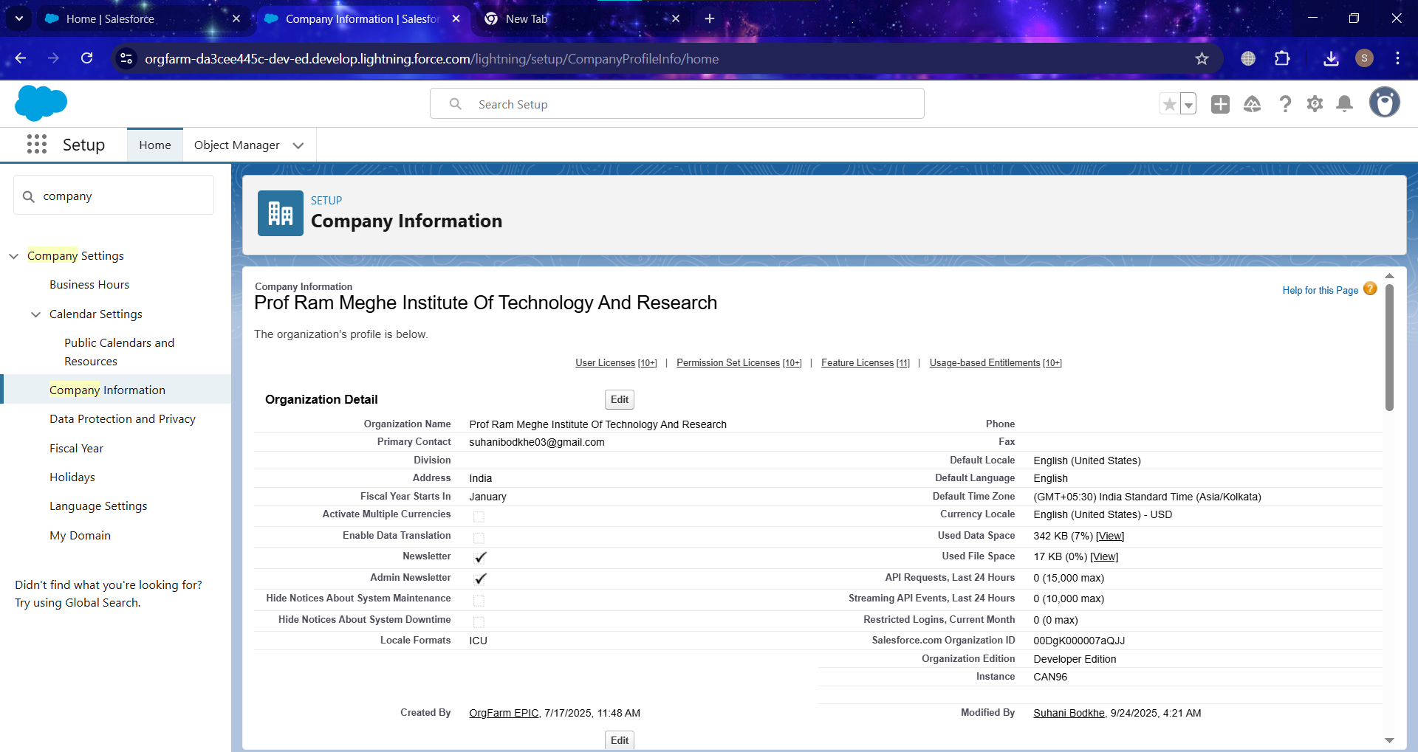Configured **Institution Name, Address, Default Time Zone, Currency, and Locale**.

**3. Business Hours & Holidays**

* 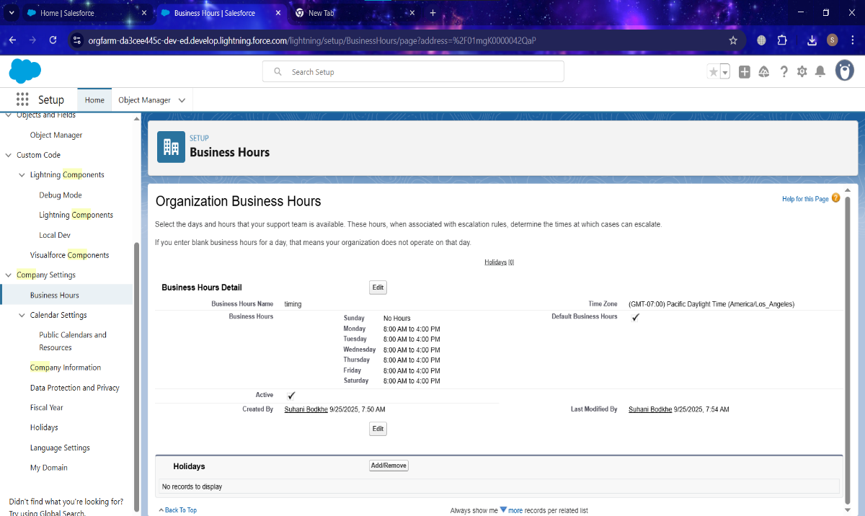Defined **Standard Business Hours** (8 AM – 4 PM, Mon–Sat )
* 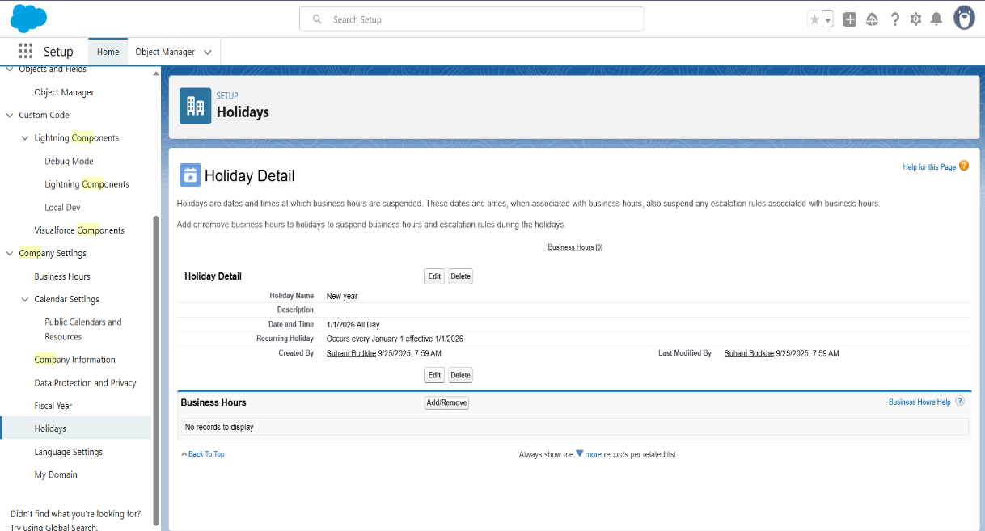Added **holidays** (e.g. New Year).

**4. Fiscal Year Settings**

* Configured **Standard Fiscal Year** (Jan–Dec).

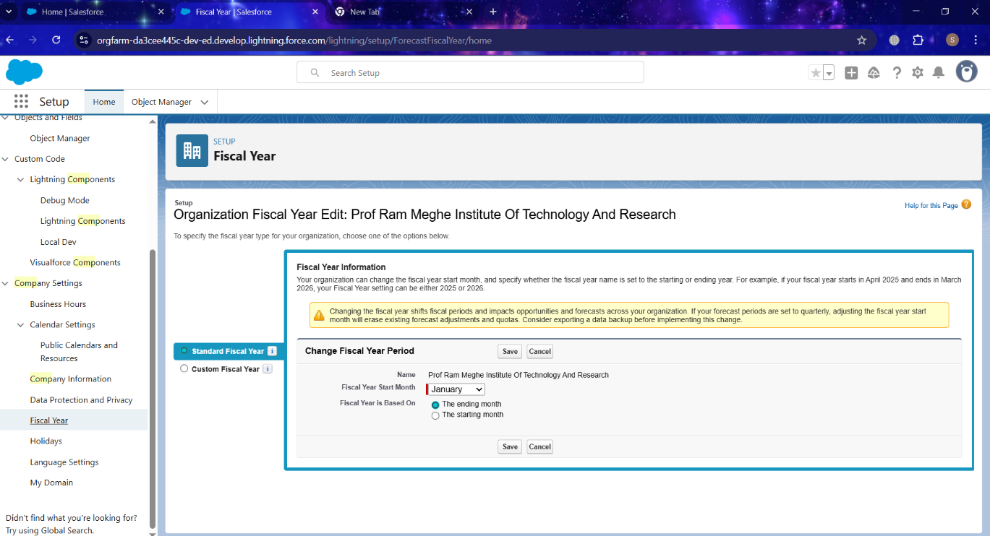

**5. User Setup & Licenses**

* Created sample users with **Salesforce licenses**:
  + **System Administrator** – Full access.
  + **Faculty User** – Limited teaching access.
  + **Student User** – Read-only/student data access.

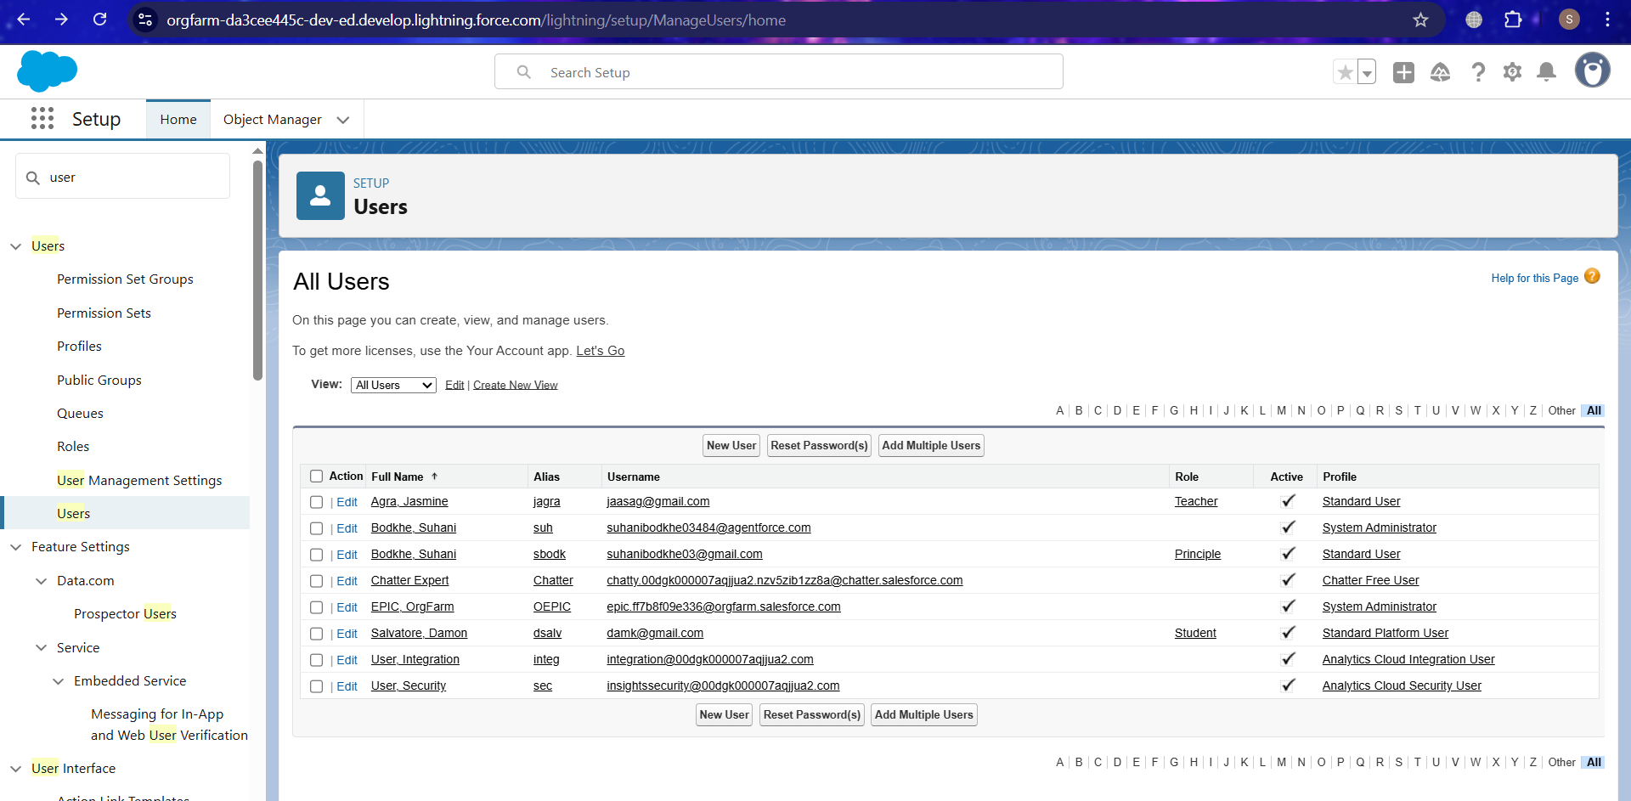

**6. Profiles**

* Created/Modified Profiles:
  + 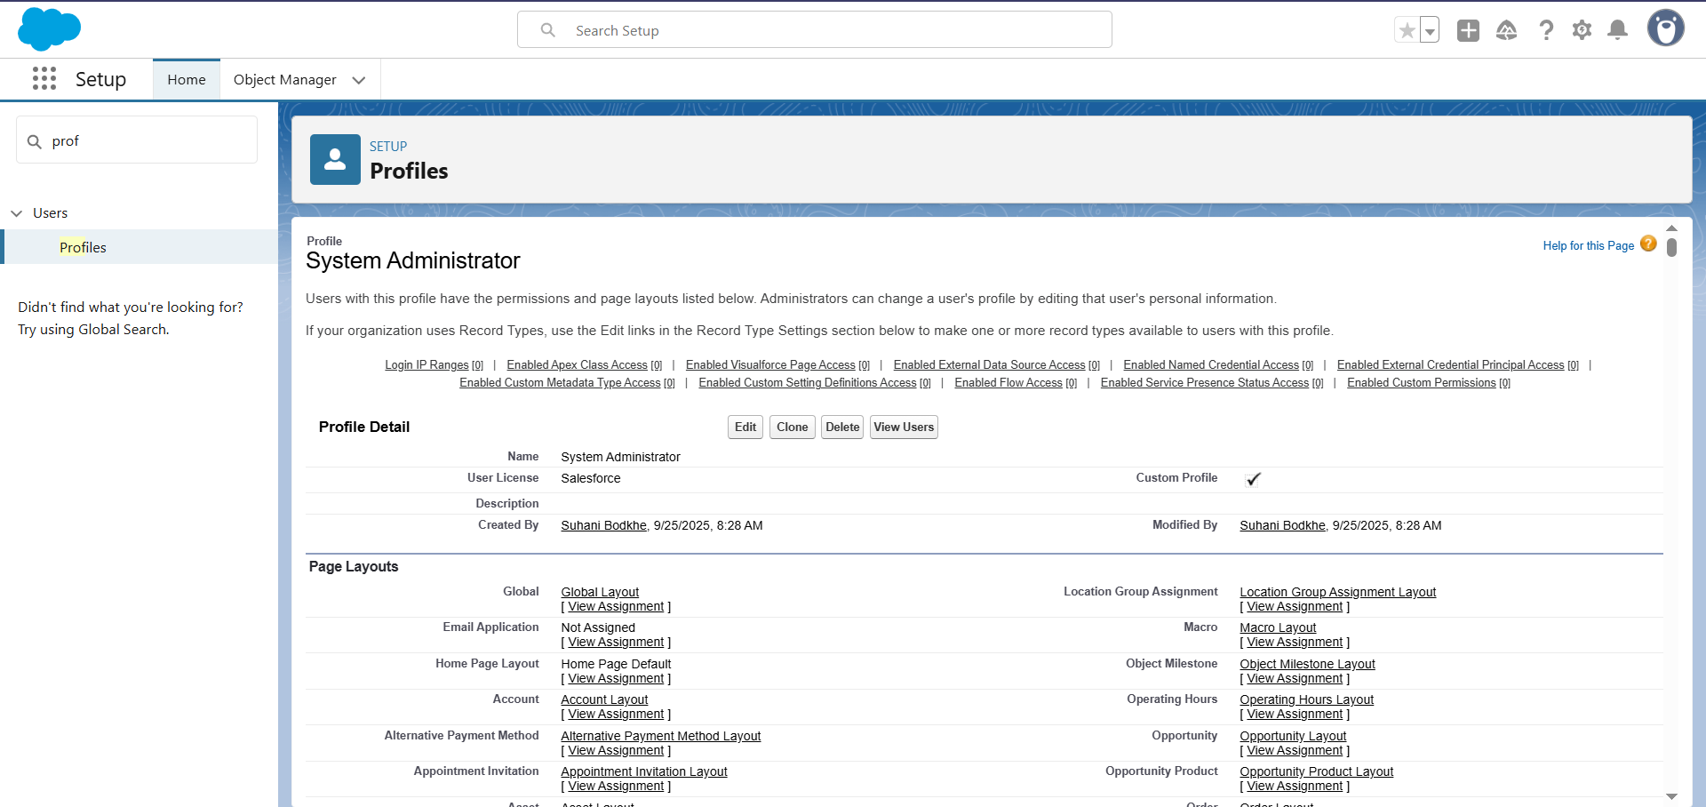**System Administrator**
  + 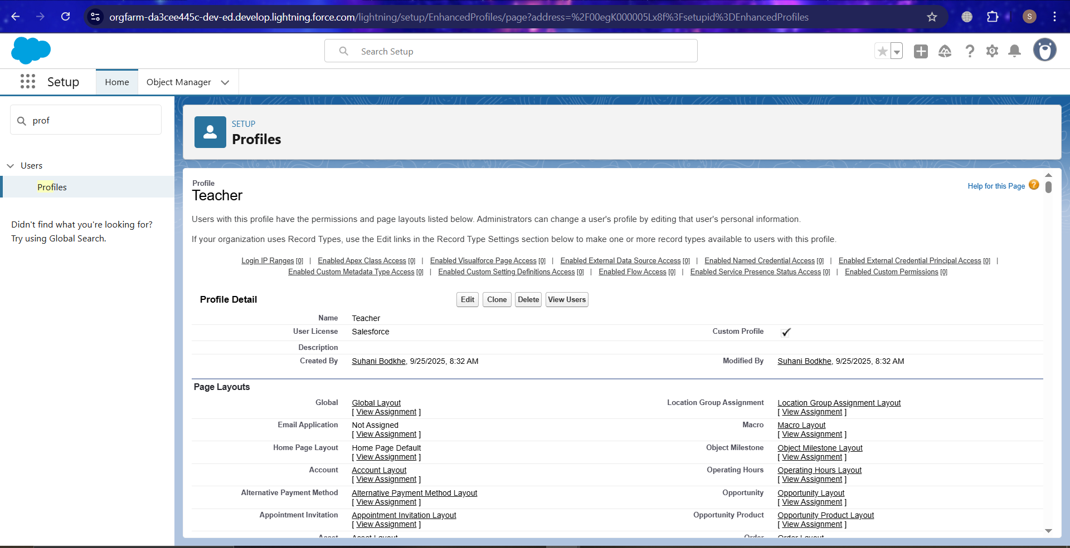**Teacher Profile** – Access to Students, Courses, Attendance, Grades.
  + **Finance Profile** – Access to Fees object.

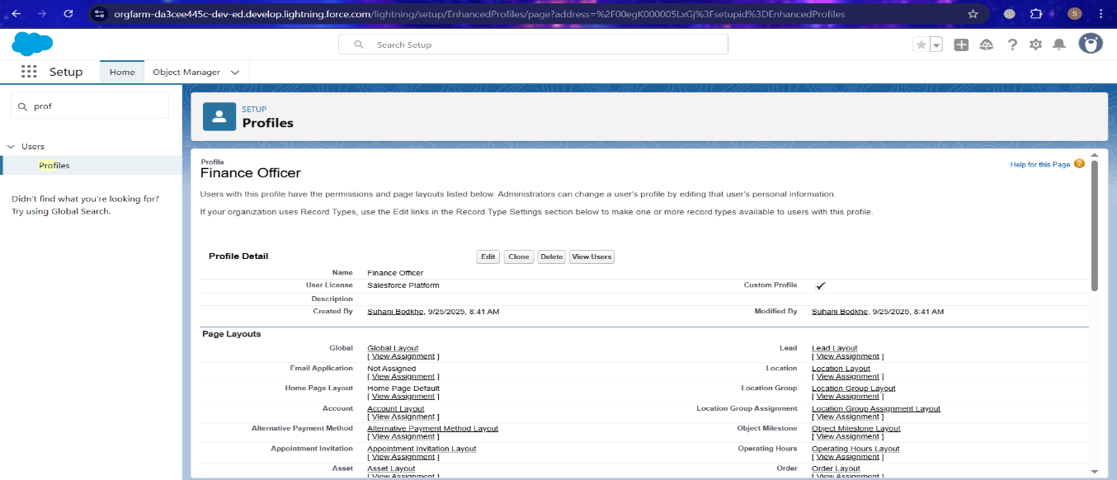**7. Roles**

* Defined Role Hierarchy:
  + **Principal (Top Role)**
    - Teacher
    - Finance Officer
    - Student

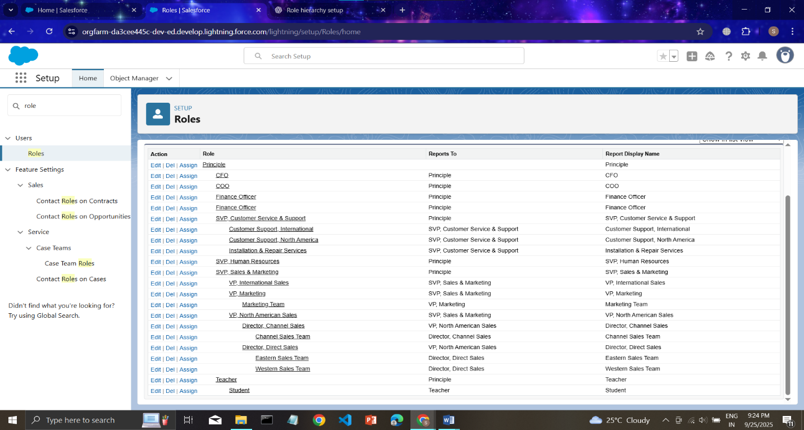

**8.Permission Sets**

* Created Permission Sets for additional access:
  + **Report Access** – Extra reporting permissions.
  + 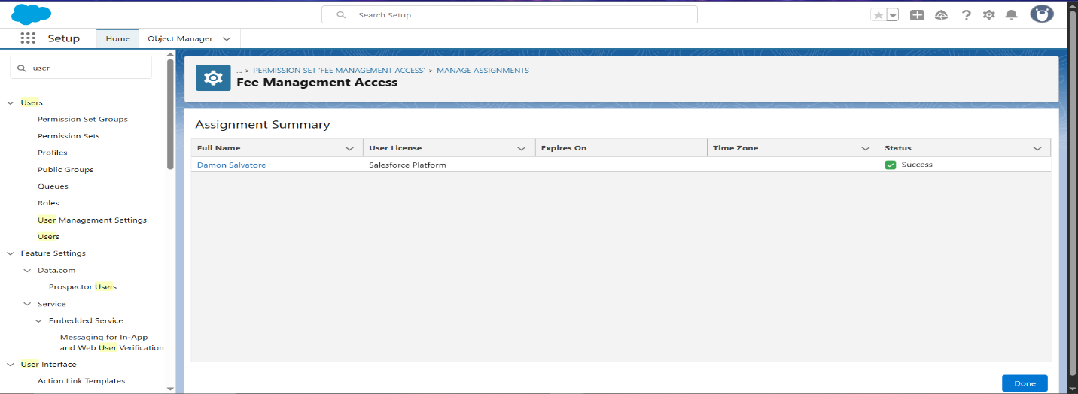**Fee Management Access** – Extended access to Fees object.

**9. Objects Created**

* **Student (Custom Object)** – Manage student details.
* **Course (Custom Object)** – Store course information.
* **Enrollment (Junction Object)** – Relationship between Student & Course.
* **Attendance (Custom Object)** – Track daily student attendance.
* **Grades (Custom Object)** – Store marks, grades, GPA.
* 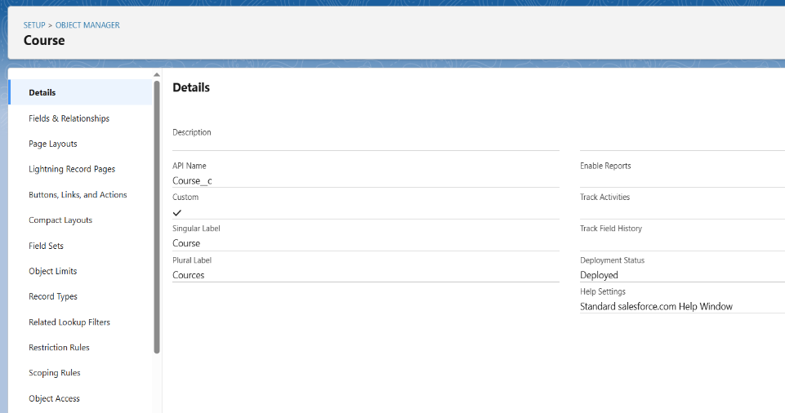**Fees (Custom Object)** – Manage payments and pending balances.

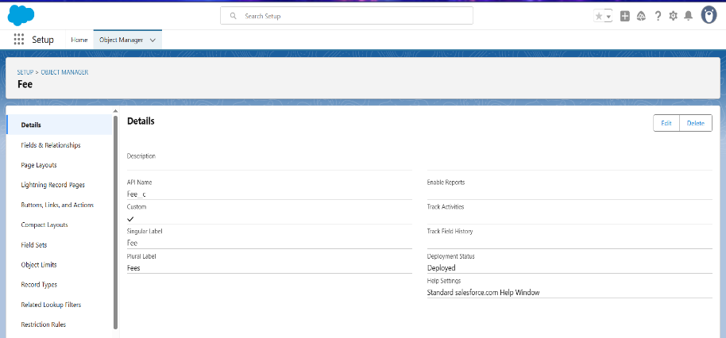

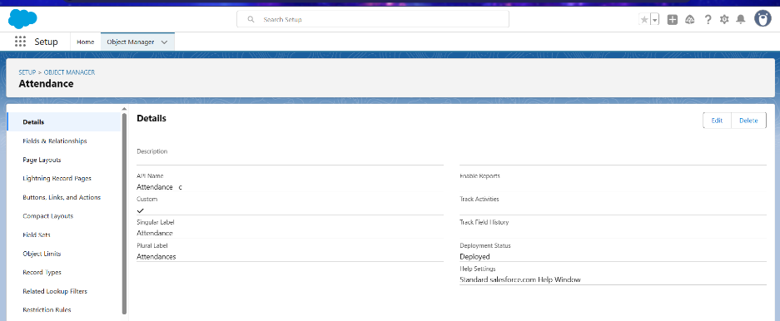

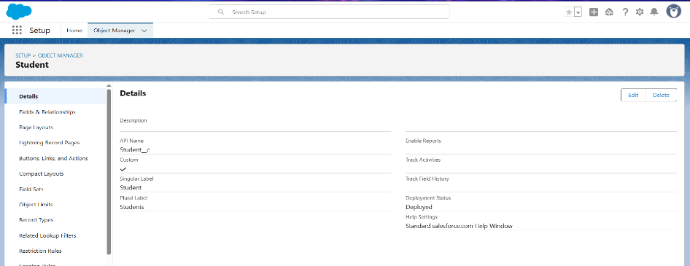

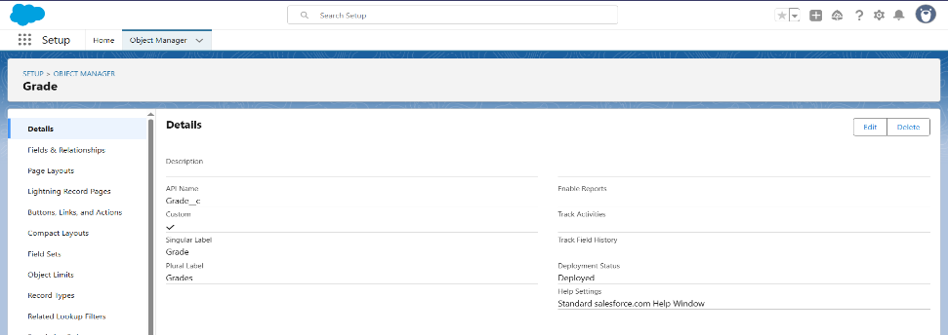

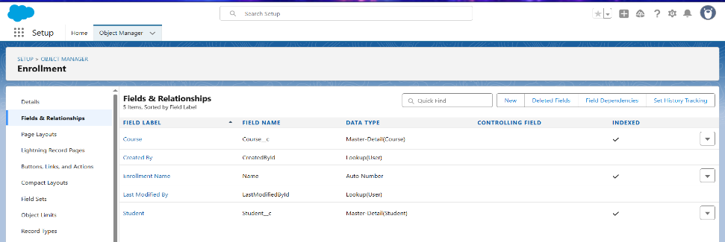

**10. OWD (Org-Wide Defaults)**

* Student → Private
* Course → Public Read Only
* Enrollment → Private
* Attendance → Private
* Grades → Private
* 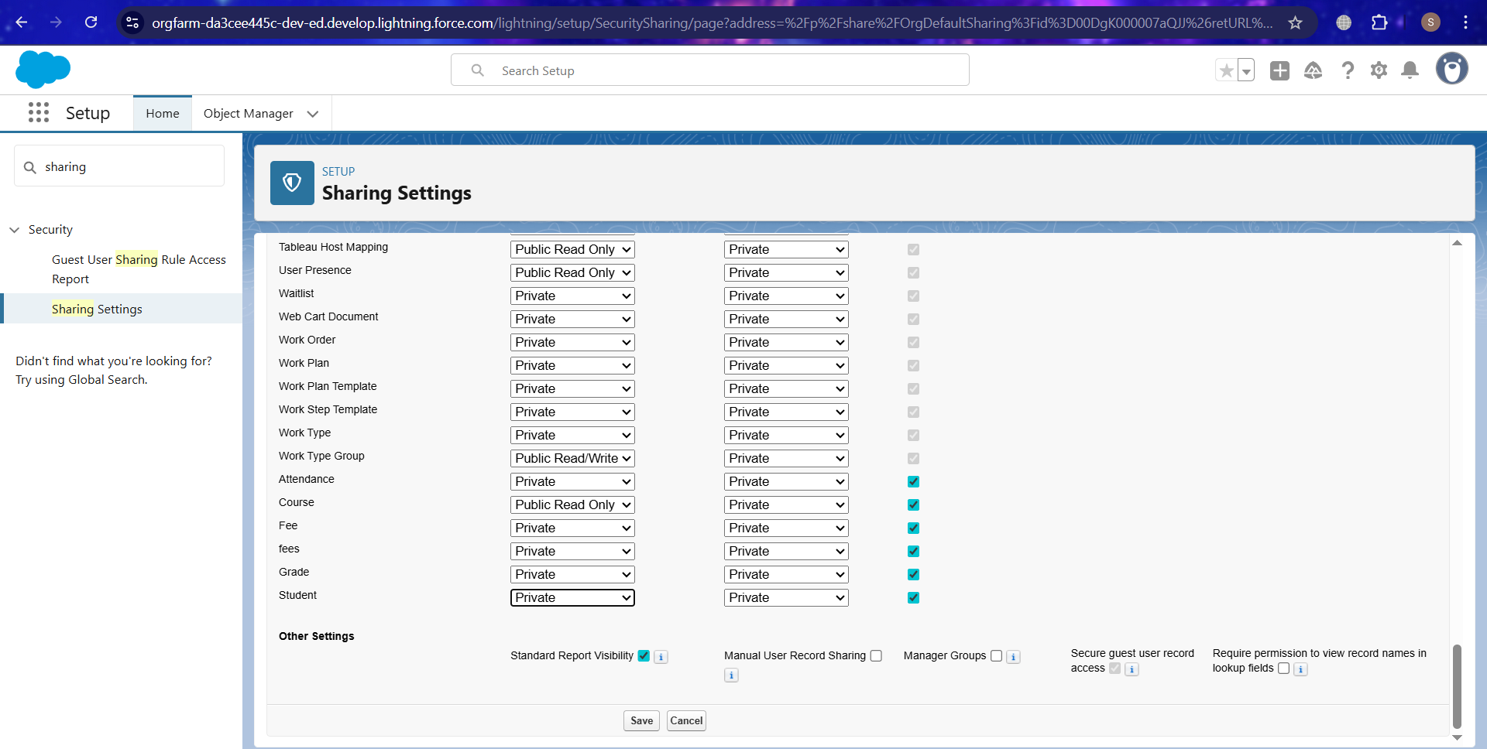Fees → Private

**11. Sharing Rules**

* 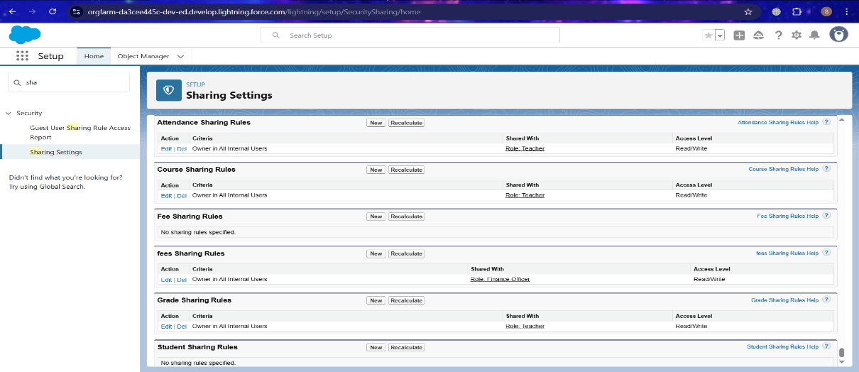Shared **Courses** with all Faculty.
* Shared **Student Records** read-only with Faculty (except Finance objects).Finance users granted access to **Fees object.**

**12. Login Access Policies**

* Enabled **Administrators Can Log in as Any User**.
* 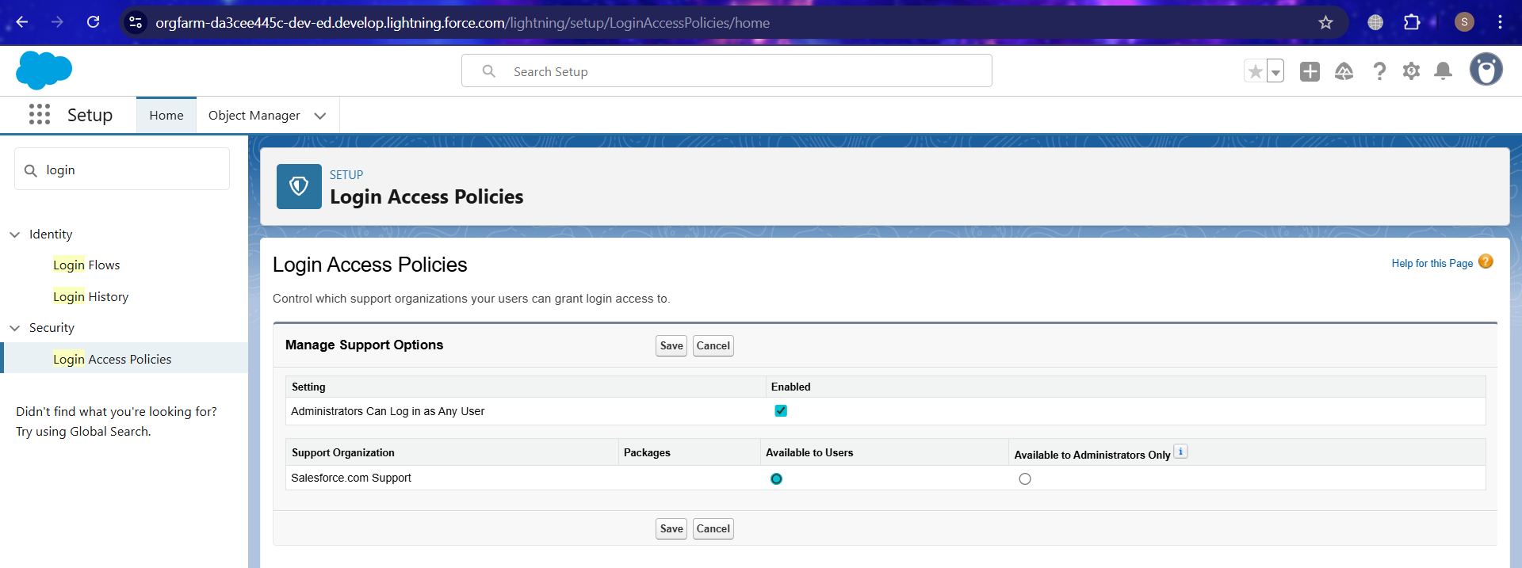Configured **Trusted IP Ranges** for secure login.

**13. Dev Org Setup**

* Enabled **Dev Hub** in Developer Org.
* Connected CLI:
* sf org login web --set-default-dev-hub --alias DevHub

**14. Sandbox Usage**

* **Not available** in Developer Edition.
* Documented sandbox usage for real-world projects (Dev, Test, UAT).

